FrontendDevelopmentwithReact.js Great Recipes Documentation.

# Introduction

* + ProjectTitle:GreatRecipes
  + TeamMembers:
    - DhanushKumar M-TeamLeader
    - AjayDaniel B
    - Gokulan S
    - Danush SV
    - Prince Martin S

# ProjectOverview

* + Purpose:TheGreatRecipesprojectaimstoprovideuserswithaplatformtodiscover, share, and manage a variety of recipes. The goal is to create an engaging and

user-friendlyexperienceforcookingenthusiasts.

* + Features:
    - Userauthenticationandprofilemanagement
    - Recipesearchandfilteringoptions
    - User-generatedcontentforsharingrecipes
    - Ratingandcommentingsystemforrecipes
    - Responsivedesignformobileanddesktopusers

# Architecture

* + ComponentStructure:
    - Majorcomponentsinclude:
      * App
      * Navbar
      * RecipeList
      * RecipeDetail
      * UserProfile
    - Componentsinteractthroughpropsandstatemanagement.
  + StateManagement:
    - TheprojectusesReduxforglobalstatemanagementtohandleuser authentication and recipe data.
  + Routing:
    - ReactRouterisusedtomanagenavigationbetweendifferentpagessuchas Home, Recipe Detail, and User Profile.

1. SetupInstructions
   * Prerequisites:
2. Node.js(version14orhigher)
3. npm(Nodepackagemanager)
   * Installation:
4. Clone the repository: git clone https://github.com/Gokulan08/Great-Recipes.git
5. Navigatetotheprojectdirectory:cdGreat-Recipes
6. Installdependencies:npm install
7. Configureenvironmentvariablesasneeded.

# FolderStructure

* + Client:
    - TheReactapplicationisorganizedasfollows:
      * src/components:Containsreusablecomponents.
      * src/pages:Containspagecomponents.
      * src/styles:ContainsCSSfilesforstyling.
      * src/images:Containsimageassets.
  + Utilities:
    - Helperfunctionsandcustomhooksarelocatedinsrc/utils.

# RunningtheApplication

* + Commands:
    - Tostartthefrontendserverlocally,run:npmstartintheclientdirectory.

# ComponentDocumentation

* + KeyComponents:
    - App:Themaincomponentthatrenderstheapplication.
    - Navbar:Navigationbarforrouting.
    - RecipeList:Displaysalistofrecipes.
    - RecipeDetail:Showsdetailedinformationaboutaselectedrecipe.
  + ReusableComponents:
    - Button:Areusablebuttoncomponentthatacceptspropsforcustomization.

# StateManagement

* + GlobalState:
    - Reduxisusedtomanagetheglobalstate,allowingforeasyaccesstouserand recipe data across components.
  + LocalState:
    - LocalstateismanagedusingReact'suseStatehookwithinindividual components.

# UserInterface

* + 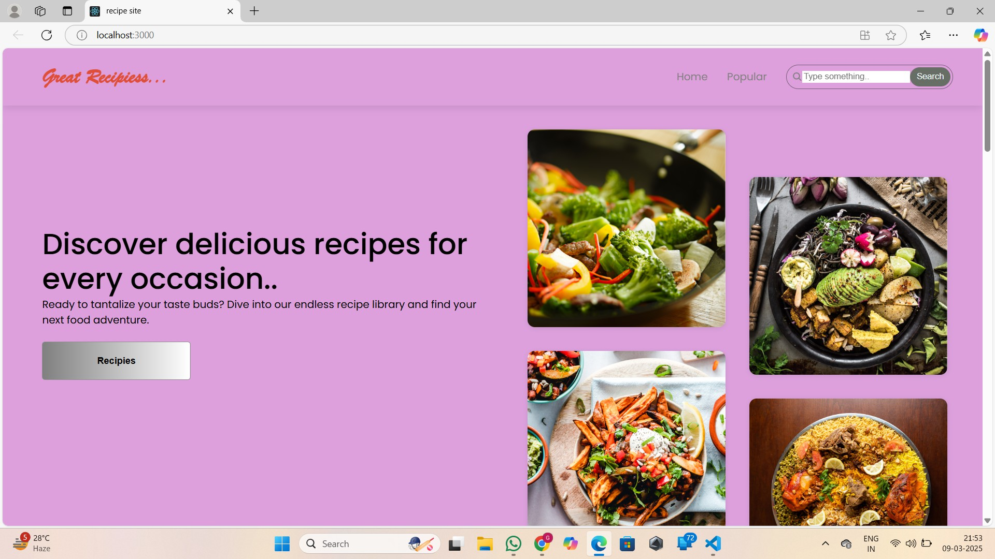Visuals:ScreenshotsofshowcasingtheUIfeatures,suchasthehomepage,recipe detail page, and user profile.

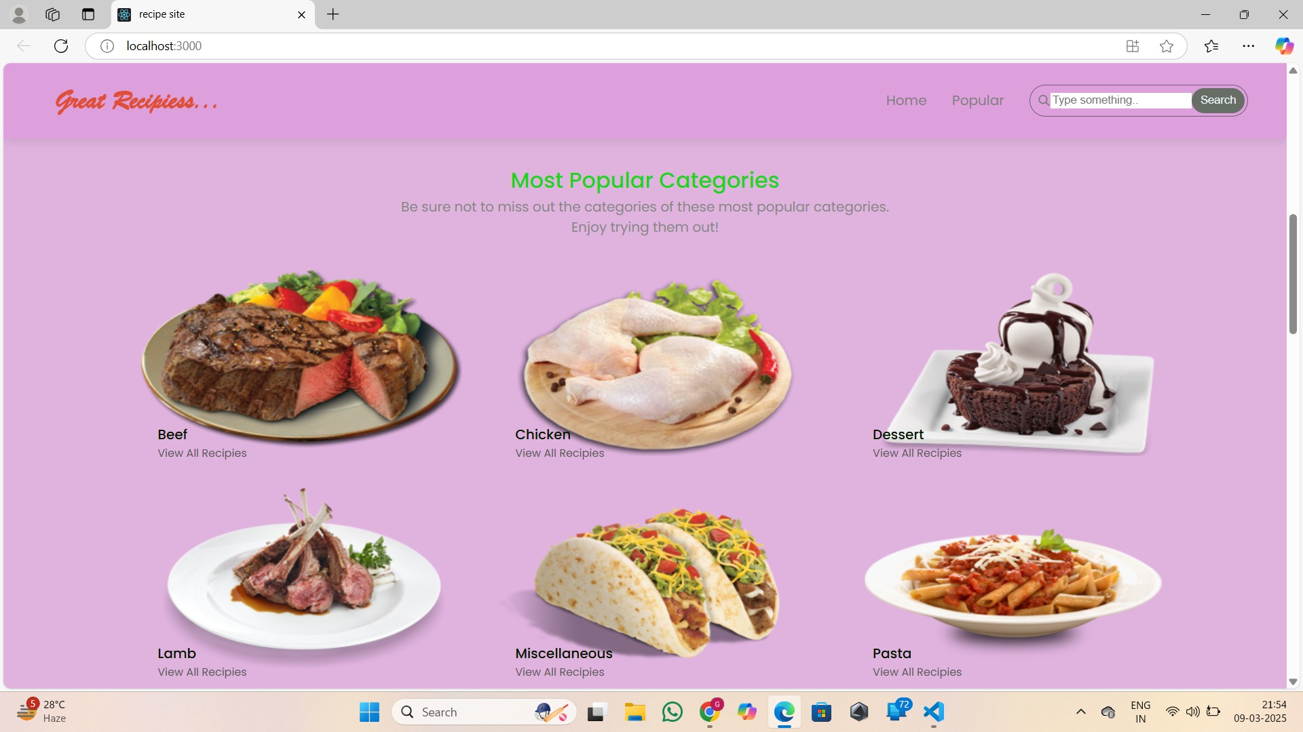

# Styling

* + CSSFrameworks/Libraries:
    - TheprojectusesStyled-Componentsforstylingcomponents.
  + Theming:
    - Acustomdesignsystemisimplementedtomaintainconsistencyacrossthe application.

# Testing

* + TestingStrategy:
    - TheprojectemploysunittestingusingJestandReactTestingLibraryfor component testing.
  + CodeCoverage:
    - CodecoverageismonitoredusingJest'sbuilt-incoveragetool.

# Screenshots

* + Visuals:Providescreenshotsoralinktoademoshowcasingtheapplication’sfeatures and design.

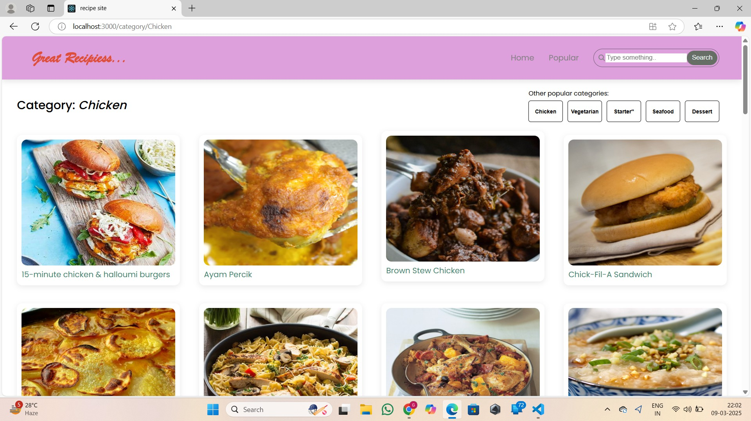

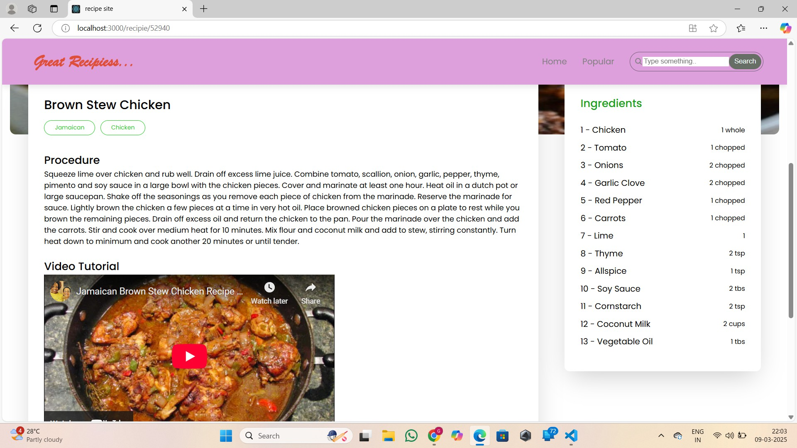

# KnownIssues

* + Bugs:
    - Documentanyknownbugsorissuesthatusersordevelopersshouldbeaware of, such as:
      * Recipesearchmayreturnincompleteresults.
      * Userprofileupdatesmaynotreflectimmediately.

# FutureEnhancements

* + Improvements:
    - Potentialfuturefeaturesinclude:
      * Addingamealplanningfeature.
      * Implementingashoppinglistgeneratorbasedonselectedrecipes.
      * Enhancingtheuserinterfacewithanimationsandtransitions.